

Business Analytics

Chapter 4 Probability



Why is Probability Important?



It Can Save Lives, too!

**Chile 2010**

* San Jose copper and gold mine caved in, trapping 33 men 2000 ft underground
  + Contacted NASA to help
  + NASA Team: Engineer, 2 Doctors, and a psychologist

**No historical data**

* Developed subjective probability estimates:
  + Success vs. Failure of rescue methods

**Results?**

* Based on probabilities the team designed:
  + 13 ft, 924 steel rescue capsule that brought up miners 1 at a time
  + All miners were rescued – some after 68 days underground



Introduction

* UNCERTAINTY
  + We don’t know everything
  + We wish we did
* **Probability:**
  + is the numerical measure of the likelihood that an event will occur.
  + Often communicated through a probability distribution
  + Helpful in providing additional information about an event.
  + Can be used to help a decision maker evaluate possible actions and determine best course of action.



Events and Probabilities



Events and Probabilities

* A **random experiment:**
  + is a process that generates well-defined outcomes.
* **The sample space** for a random experiment:
  + All possible outcomes
* Examples:
  + A coin toss – Sample Space = Heads, Tails
  + Rolling a die – Sample Space = 1, 2, 3, 4, 5, 6
* An **event** is defined as a collection of outcomes.

|  |  |
| --- | --- |
| **Random Experiment** | **Experimental Outcomes** |
| Toss a coin | Head, tail |
| Roll a die | 1, 2, 3, 4, 5, 6 |
| Conduct a sales call | Purchase, no purchase |
| Hold a particular share of stock for one year | Price of stock goes up, price of stock goes down, no change in stock price |
| Reduce price of product | Demand goes up, demand goes down, no change in demand |

# Events and Probabilities



## California Power & Light Company (CP&L).



Events and Probabilities

Other Examples: Random Experiments and Experimental Outcomes

* + CP&L is starting a project designed to increase the generating capacity of one of its plants in southern California.
  + Analysis of similar construction projects indicates that the possible completion times for the project are 8, 9, 10, 11, and 12 months.

## Events:

* + Event that project is completed in 10 months or less
    - C = {8, 9, 10}
  + Event that project is completed in less than 10 months
    - C = {8, 9}
  + Event that project is completed in more than 10 months
  + Event that project is completed between 9 and 11 months

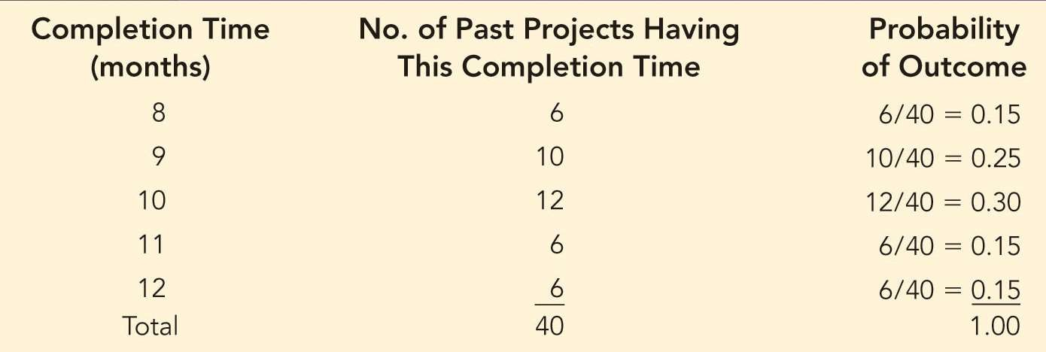

Events and Probabilities

* If there have been 40 already completed projects, then based on previous data,
* **What are the probabilities of each outcome?**



Events and Probabilities

**How to calculate probability of an event?**

* The **probability of an event:**
  + is equal to the sum of probabilities of outcomes for the event.
* CP&L example: Let *C* be the event that the project is completed in 10 months or less,
* The probability of event *C*,

*P*(*C*) = *P*(8) + *P*(9) + *P*(10) = 0.15 + 0.25 + 0.30 = 0.70

* We can tell CP&L management that there is a 0.70 probability (70% chance) that the project will be completed in 10 months or less.

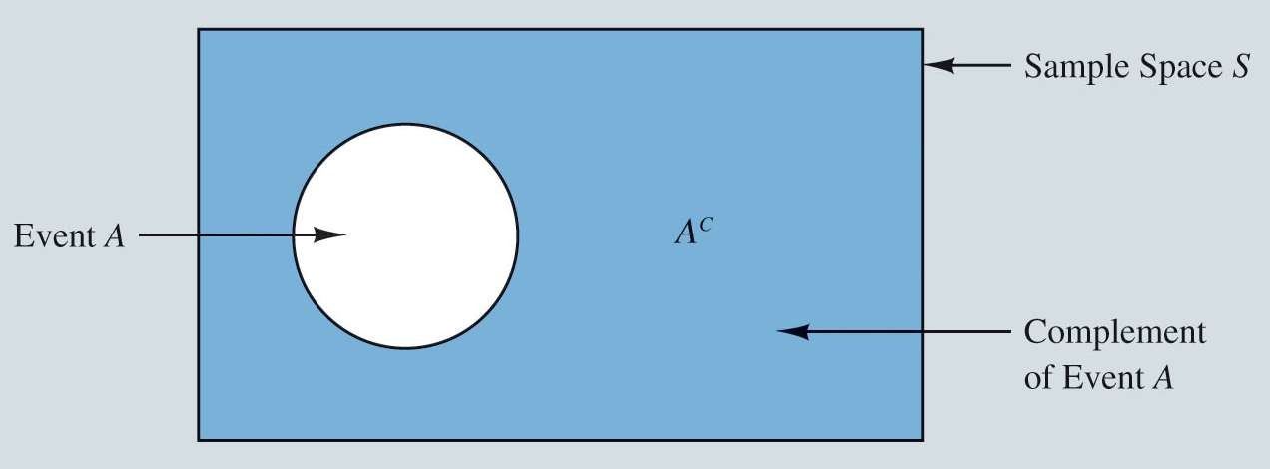

Some Basic Relationships of Probability

Complement of an Event Addition Law



Some Basic Relationships of Probability

**Complement of an Event:**

* Given an event *A*, the **complement of A:**
  + is defined to be the event consisting of all outcomes that are *not* in *A.*

**Example:**

*Sample space: Roll a Die S = {1, 2, 3, 4, 5, 6}*

*Event: A = {1, 2, 3, 4}*

A complement = 𝐴C = {5, 6}

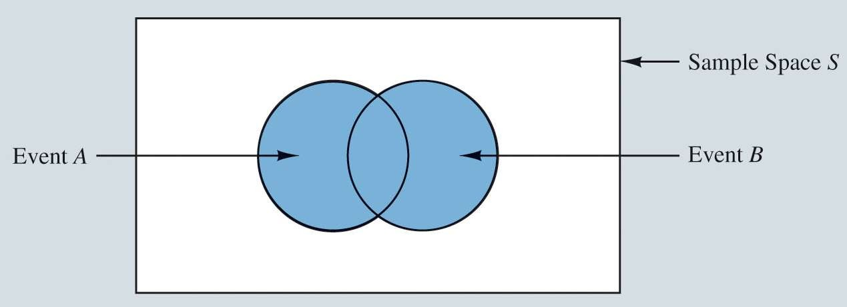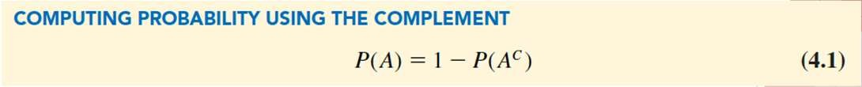

Some Basic Relationships of Probability

In any probability application, either event A or its complement 𝐴Cmust occur!

* Example:
  + Roll a Dice
  + S = {1, 2, 3, 4, 5, 6}
  + A = Roll an Even = {2, 4, 6}
  + A^c = Roll an Odd = {1, 3, 5}

If you don’t roll and even #, you must roll an odd #!

The probability of an event *A* can be computed easily if the probability of its complement is known.



Some Basic Relationships of Probability

**Union of 2 Events**

* Given two events *A* and *B*, the **union of *A* and *B***
  + is defined as the event containing all outcomes belonging to *A* or *B* or both.
* The union of *A* and *B* is denoted by *A*  *B*.

**Example:**

*Sample space: Roll a Die S = {1, 2, 3, 4, 5, 6}*

*Event: A = {1, 2, 3, 4}*

*Event B = {5}*

A U B = {1, 2, 3, 4, 5}

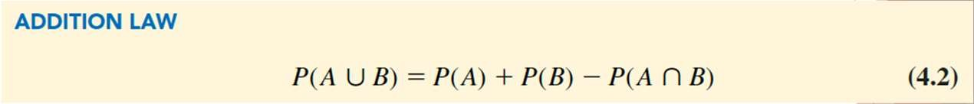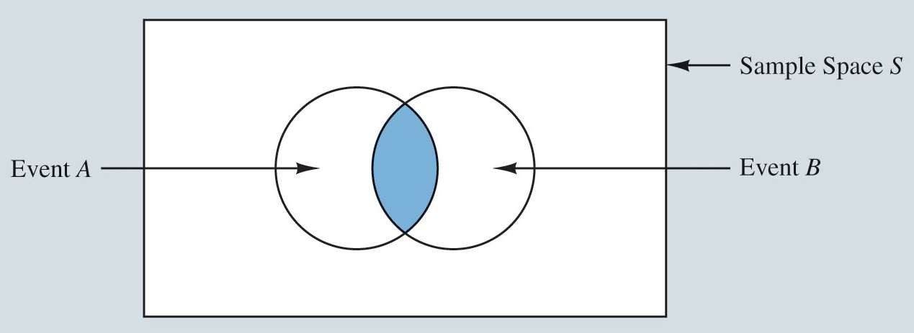

Some Basic Relationships of Probability

**Intersection of 2 Events**

* Given two events *A* and *B*, the **intersection of *A* and *B***
  + is the event containing the outcomes that belong to both *A* and *B*. The union of *A* and *B* is denoted by
* The intersection of *A* and *B* is denoted by

*A*  *B*.

**Example:**

*Sample space: Roll a Die S = {1, 2, 3, 4, 5, 6}*

*Event: A = {1, 2, 3, 4}*

*Event B = {2, 4, 6}*

*Event C = {5}*

A Ո B = {2,4} A Ո C = {ø}



Some Basic Relationships of Probability

**What is the probability that at least one of two events will occur?**

**What is the probability that Event A OR Event B will happen?**

* A special case arises for **mutually exclusive events**:
  + If the occurrence of one event precludes the occurrence of the other.
  + If the events have no outcomes in common.

# Some Basic Relationships of Probability

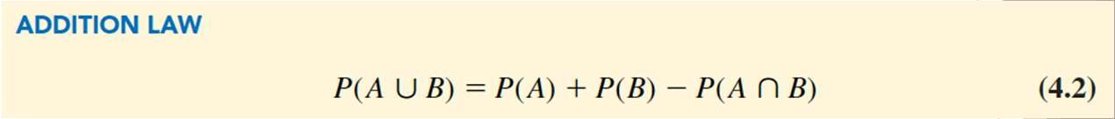

## Example:

* + - * Sample space: Roll a Die
      * S = {1, 2, 3, 4, 5, 6}
      * Event: A = {1, 2, 3, 4}
      * Event B = {2, 4, 6}
      * Event C = {5}

## What is the P(A U B)?

P(A) = 4/6 = .667 P(B) = 3/6 = .5

P(A n B) = 2/6 = .333

P(A U B) = .667 + .5 - .333 = .834 = 5/6

=P (1,2,3,4,6)

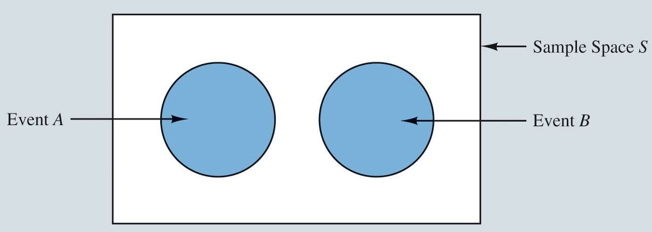

Some Basic Relationships of Probability

* A special case arises for **mutually exclusive events**:
  + If the events have no outcomes in common.

**Mutually Exclusive Events**

* Example:
  + Sample space: Roll a Die
  + S = {1, 2, 3, 4, 5, 6}
  + Event: A = {1, 2, 3, 4}
  + Event B = {5, 6}

P(A) = 4/6 = .667 P(B) = 2/6 = .333 P(A n B) = 0/6 = 0

P(A U C) = .667 + .333 - 0 = 1

* What is the P(A U C)?



Conditional Probability

Independent Events Multiplication Law Bayes’ Theorem



Conditional Probability

* **Conditional probability**:
  + When the probability of one event is dependent on whether some related event has already occurred.
* Illustration: Lancaster Savings and Loan:

**Does the probability of a customer defaulting on a mortgage differ by marital status?**

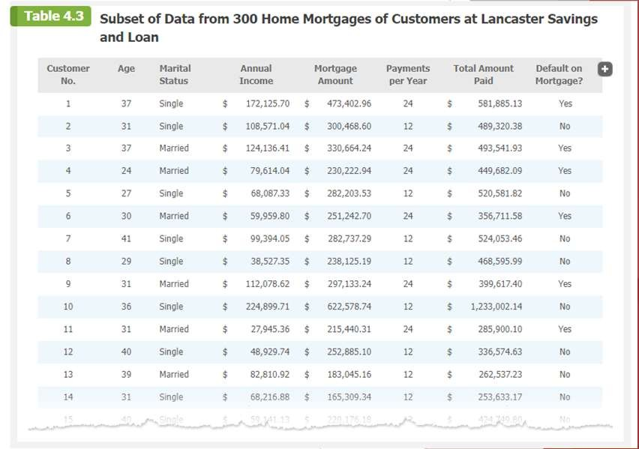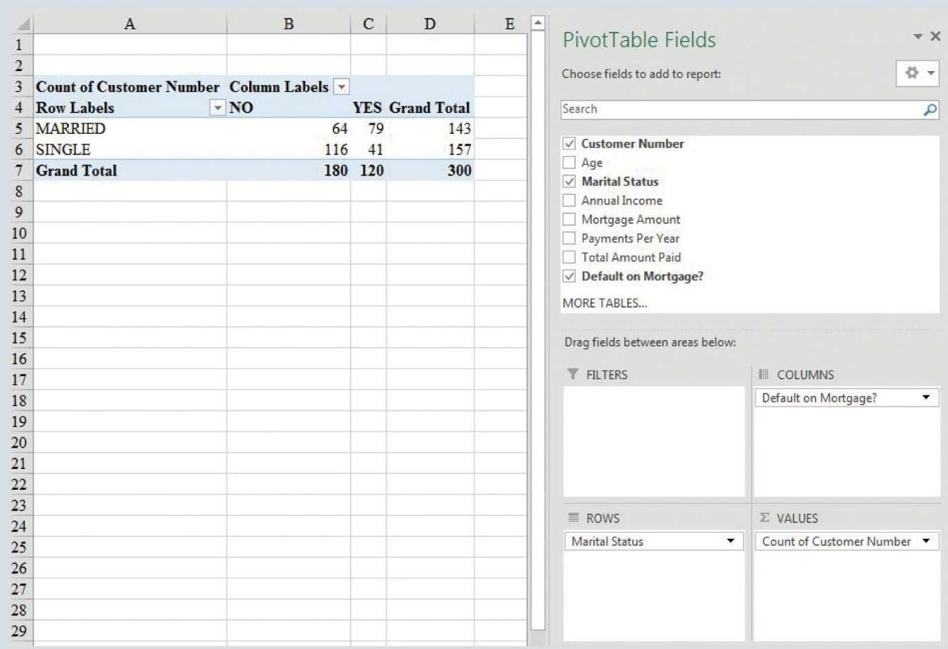

Conditional Probability

* **Does the probability of a customer defaulting on a mortgage differ by**

**marital status?**

* S = event that a customer is single
* M = event that a customer is married
* D = event that a customer defaulted on their mortgage
* D^C = event that a customer did not default on their mortgage



Conditional Probability

Figure 4.5: PivotTable for Marital Status and Whether Customer Defaults on Mortgage



Conditional Probability

Crosstabulation of Marital Status and if Customer Defaults on Mortgage

The probability that a customer defaults on his or her mortgage is

120 300 = 0.4.

The probability that a customer does not default on his or her mortgage is

1  0.4 = 0.6 or 180 300.

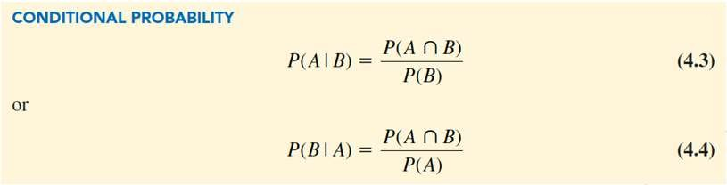

|  |  |  |  |
| --- | --- | --- | --- |
| **Marital Status** | **No Default** | **Default** | **Total** |
| **Married** | 64 | 79 | 143 |
| **Single** | 116 | 41 | 157 |
| **Total** | 180 | 120 | 300 |



Conditional Probability

* **Joint probabilities:**
  + When values give the probability of the intersection of two events
* **Marginal probabilities:**
  + Sum of the joint probabilities in the corresponding row or column of the joint probability table.
* Conditional probabilities can be computed as the ratio of joint probability to a marginal probability.

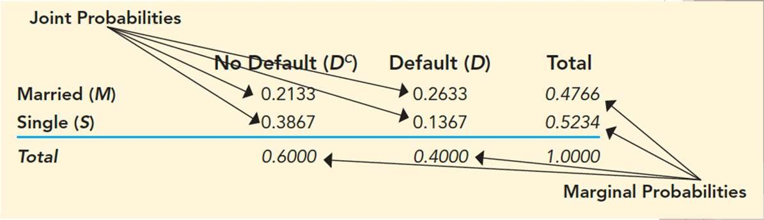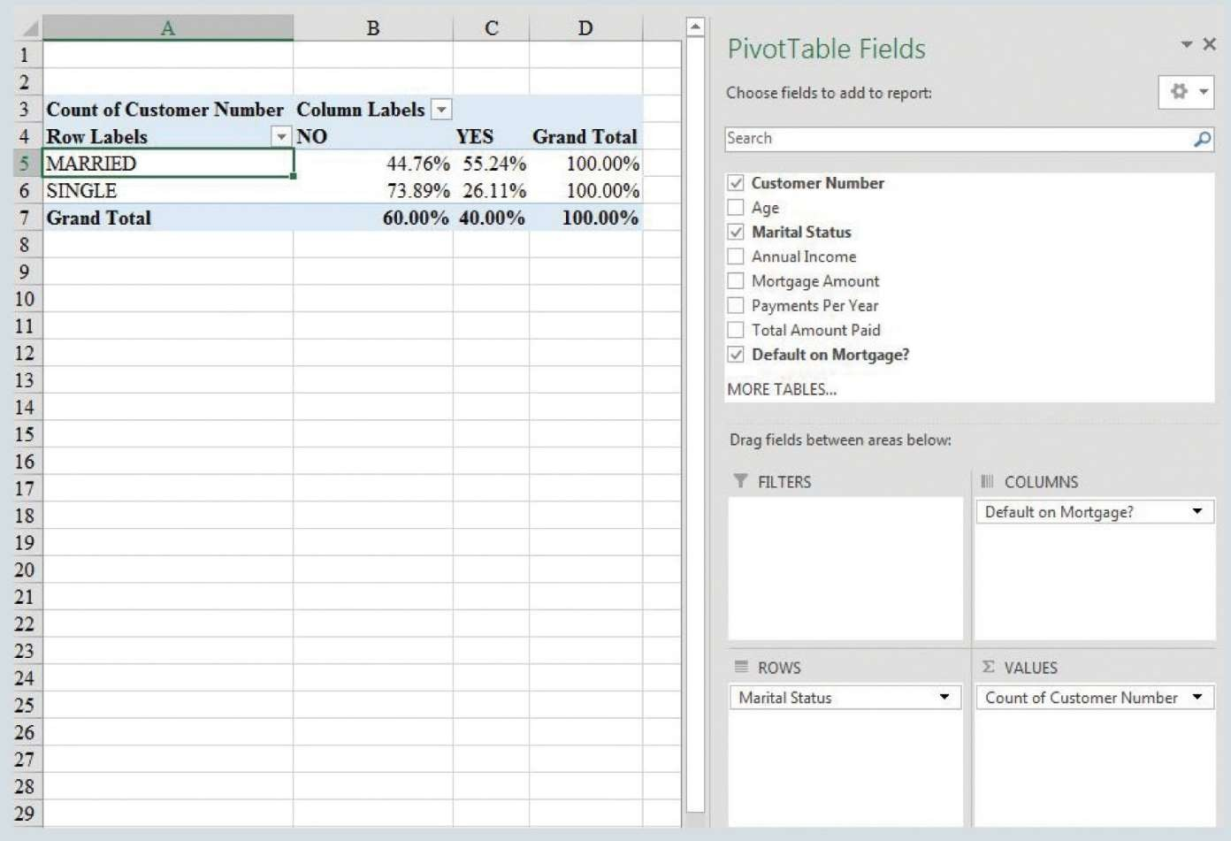

Conditional Probability

Table 4.5: Joint Probability Table for Customer Mortgage Prepayments



Conditional Probability

Figure 4.6: Using Excel PivotTable to Calculate Conditional Probabilities